Correlation One: NYC Datathon

Team: Skulk

Team Members:

Niki Athanasiadou

Uday Krishna

Suraj Vidya

Andrew Bailey

Resources:

<https://github.com/andrewwbailey/nyc-datathon>

**Note:** Detailed information on GitHub.

Question: Can we use job posting data to predict the influence of a sector on the U.S. economy?

Datasets Used:

LinkedUp

* Used created_date to signifiy a new job opening without repeats
* Used Thomson Reuters Economic Sector classifications that were associated with companies in the dataset.

Quarterly Federal GDP

NASDAQ Daily Index Values

Indicators (Proxies):

New job postings are an indicator of growth in a specific sector.

Growth in GDP indicator of economic growth.

Growth in NASDAQ index indicator of economic growth.

Results:

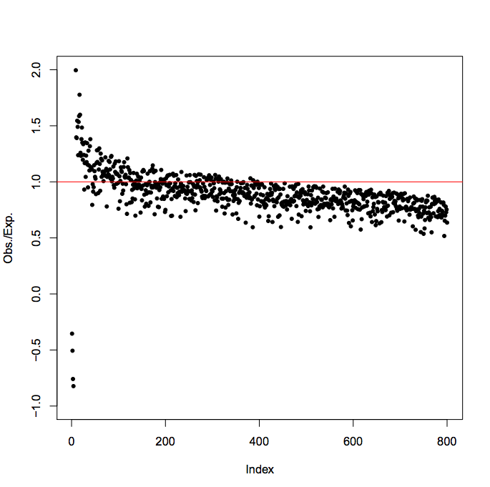

**Top 3 Sectors Most Correlated with NASDAQ**

1. Consumer Non-Cyclical Jobs
2. Consumer Cyclical Sector Jobs
3. Healthcare
4. Industrial jobs

**Sectors Least Correlated with NASDAQ**

1. Utility
2. Cyclical Consumer Goods & Services.

Utility Jobs

